# 

## Project Structure

Project is organized using five different solution folders inside visual studio solution folder. This project solution is using nugget package to managing all the framework level dependencies. All package configuration is inside the project directory itself.

1. DAL – Data Access Layer
2. Model
3. Presentation
4. Reports
5. Test

DAL

In this project solution folder there are two project.

# 1.AdventureWork.Data.Context : This project is responsible for making all the context regarding to database object. This project is depend on Entity framework for managing all connections and database.

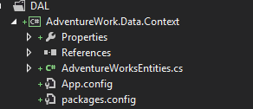

# 2. AdventureWork.Data.Infrastructure : This project is responsible for read operation on database through entity framework through lambda expression. This is implementing Repository Pattern for accessing database.

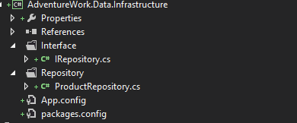

Domain

Model is generated from database directly via **Entity Framework database first** approach.

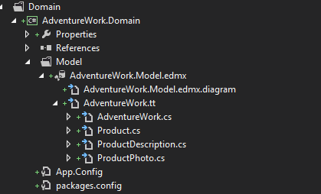

Presentation

This is the main Web component for all solution. It is holding MVC framework and all client side html. It is using Razor view Engine to rending the view page on the client side.

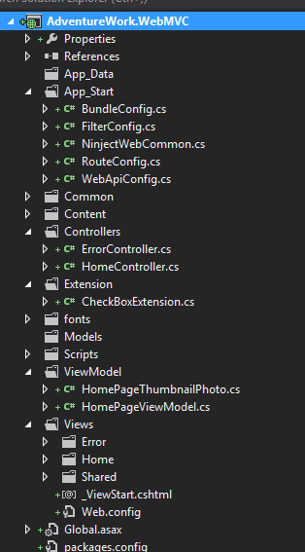

Reports

This solution folder have all the reports about code structure, code metrics index and profiler sampling and dependencies graph. All the reports have been generated with Visual studio 2012 tools.

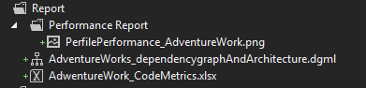

Test

This folder structure has two main Test project for solution.

# 1.AdventureWork.WebMVC.Tests

This project has all unit testing test method and results.

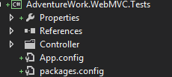

# 2.AdventureWork.IntegrationTest

This project has all component testing methods.



